|  |
| --- |
|  |
|  |
| April 26, 2021  Zoo and Wildlife  Nutrition Foundation |

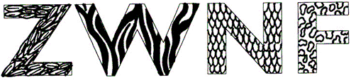

# A picture containing text, clipart Description automatically generatedA picture containing frog Description automatically generated Table of Contents

The most current information on the Foundation, as well as a link to donate in support of our important work can be found at: <https://nagonline.net/zwnf/>. We encourage your continued interest in the Foundation and its mission, as well as your support for the work that the Foundation does to train the next generation of zoo nutritionists!

Thank you!

*RESEARCH & PROJECTS*

*7 - SCARF*

*11 - Research Grant Fund*

*11 - Past Updates*

*ABOUT*

*6 - Conference announcement  
10 - Financial Statements*

*12 - How to become a part of the ZWNF*

*13 - Donor Recognition*

|  |
| --- |
| A flamingo standing in front of a bird  Description automatically generatedZoo and Wildlife Nutrition Foundation *INTRODUCTION 3 - Our Mission Statement*  *4 - Letter from the President*  *14 - Get to know our board* |
| *“I didn’t save the environment, but I did try to help the world’s animals survive by being a Zoo Nutritionist.”   - Sue Crissey* |
| ZWNF Definition, Mission, and Focus  A picture containing cat, black  Description automatically generatedThe Zoo and Wildlife Nutrition Foundation (ZWNF) is a Texas nonprofit corporation formed by concerned individuals to promote zoo and wildlife nutrition.  Our mission is to (a) provide nutrition education and advice for captive feeding programs in concert with the Association of Zoos and Aquariums Nutrition Advisory Group (NAG); and (b) participate in, and contribute to, global and regional nutrition research programs.  There are several ways in which we accomplish this. We maintain funds to support nutrition education and training. We administer a portion of those monies via the Sue Crissey Animal Nutrition Residency Fund (SCARF) which is pivotal in training the next generation of zoo nutritionists. We provide technical, financial, and administrative support for the NAG and its website (https://nagonline.net). At the same time, we facilitate the procurement and management of funds to support the ZWNF/NAG Conference on Zoo and Wildlife Nutrition, as well as to support research projects that further the understanding of exotic animal nutrition. |
| FROM THE PRESIDENT’S DESK  Hello Everyone!  I am writing from a very different place physically, mentally, emotionally, and spiritually than I was just a year ago. It is amazing how much has changed and, yet, how much has stayed the same. On one hand we wear masks and stay physically separated from those not in our immediate bubble, and on the other hand, the animals for which we care need to be fed every day, and that mission has remained consistent when so many things have not. The Foundation has not been unchanged by the pandemic.  As we speak with colleagues, we share stories of our challenges with food procurement, supplies, pricing, and budget management, but the most common stories revolve around people – our families, our staff, our greater zoo teams. At a time when we remain focused on making sure we continue to provide the best nutrition for the animals in our care, we are also focused on the most valuable resource we have – our personal relationships and the people with whom we share our lives. With this fifth annual report, we are happy to share some of the adjustments we’ve made to be more resilient and responsive to needs of the field of zoo nutrition into the future.  Among other things, the Board of Directors decided to suspend our travel and small research grant programs for the year. We will post announcements about the grant applications for 2021 and are excited to announce new grant opportunities. We hope this will allow everyone to take greater advantage of these opportunities through the coming year.  As always, we encourage your continued interest in the Foundation and its mission, as well as your support for the work that the Foundation does to train the next generation of zoo nutritionists! Thank you! |

*“Let your food be your medicine.”*

2021 ZWNF CONFERENCE

Our conference is held every other year at unique locations across the world.   
The 2019 conference was held in Saint Louis, MO.

Virtually, everywhere!

*Despite our best intentions, it’s not possible to plan for an in-person meeting in 2021. However, in the name of making it easier to attend, we are excited to announce that we will be holding the ZWNF/NAG Fourteenth Conference on Zoo and Wildlife Nutrition virtually. As this is a very recent development, we are still working on the details of how this is going to work.*

*That said, we’re always looking for Conference Committee members – anyone interested in contributing to making the next conference great, please speak up! Jaap Wensvoort (*[*jwensvoort@torontozoo.ca*](mailto:jwensvoort@torontozoo.ca)*) is our Conference Chair, and you can reach out to him to take part in the fun!*

*We are still exploring how to make this virtual conference feel as if we are all together. If over this time of many virtual meetings you have utilize ways to still feel close even though we are virtual please reach out to any board member on the foundation.*

SUSAN CRISSEY ANIMAL NUTRITION RESIDENCY FUND

SCARF was established on November 14, 2002, by the Chicago Zoological Society and the NAG. SCARF was established to acknowledge and honor the significant impact that Sue Crissey, PhD had on the field of zoo nutrition during her fifteen (15) years at Brookfield Zoo. Sue died at 51 after an extended battle with ovarian cancer. During Sue’s time at the Brookfield Zoo, she expanded the nutrition program from one of diet purchase and preparation to a program of cutting-edge research and problem solving. She led the development of the institutional coalition called the Zoo Nutrition Network. She and her staff were active in publishing many papers and worked to integrate zoo animal nutrition research with nutritional studies of wild-living animals. One of Sue’s greatest commitments was to train, professionally develop, and engage the next generation of zoo nutritionists. To that end, Sue participated in the training of three residents during her time at Brookfield and those individuals became successful zoo nutritionists at other AZA zoos. It is the hope that SCARF will continue to celebrate Sue’s tremendous achievements and contributions to expanding the field of zoo animal nutrition by providing support for residencies in zoo animal nutrition that will improve the welfare of animals in zoos and aquariums.

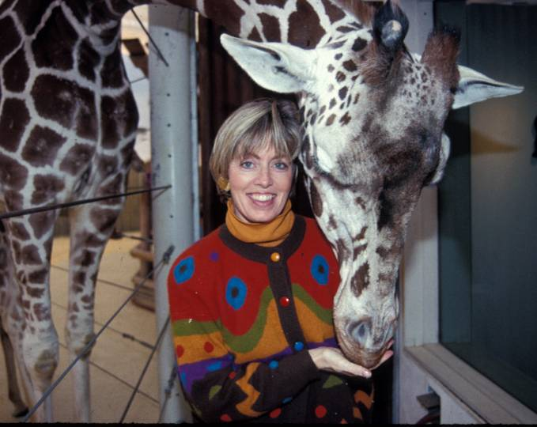

Photo by:  
 Paul Fahy

*SCARF Residents*

*2007 Kibby Treiber, PhD* -Fort Worth Zoo. Current position, Zoo Nutritionist, Miami Zoo

*2011 Adam Reppert, MS, RD, LDN* – Fort Worth Zoo. Current position, Staff Nutritionist, Fort Worth Zoo

*2020 Siga Lipinskas, MS* – Toronto Zoo. Current Resident

And the new SCARF Resident is … Siga Lapinskas

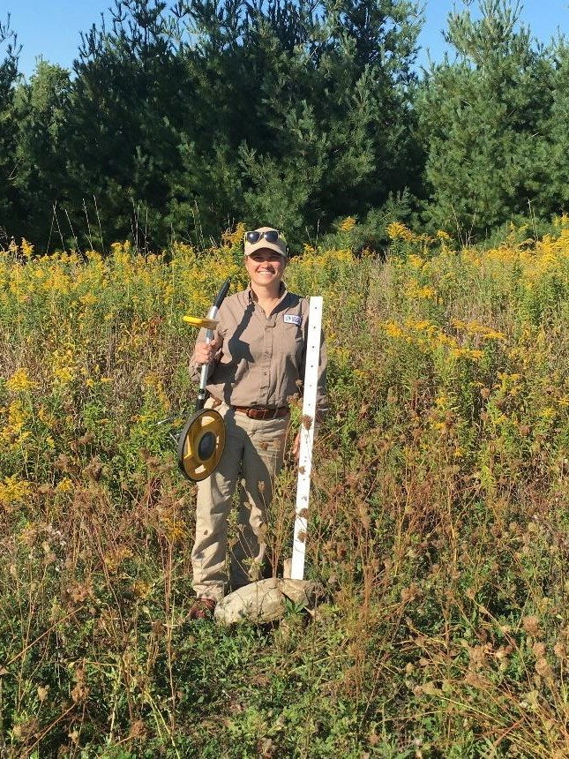

*Toronto Zoo was pleased to announce in May of 2020 they were finally able to begin training Siga Lapinskas as their SCARF resident. Siga started her career as a summer nutrition intern at the Fort Worth Zoo. She enjoyed it so much she changed her major upon returning to Colorado State University. She completed a Master of Science from Penn State as well as interned at Lincoln Park Zoo. After completing those, Siga went on to complete a 6-month fellowship at San Diego Zoo Global.*

2020 6-Month Report by SCARF Resident Siga Lapinskas

*Over the past 6-months Siga Lapinskas has been working at the Toronto Zoo. She has participated in a variety of activities such as nutrition and commissary management, browse harvesting and unique projects special to the Toronto Zoo. One of the special projects she had the opportunity to work on was implementing a feeding plan for a large pack of artic wolves. She worked alongside the keepers, supervisor, and nutritionist to organize incremental feeding plans that follow energy requirements and re-introducing diet variation such as fasting carcasses, and whole animals.*

**2020 Financial Statements**

One of the main roles of the ZWNF and NAG is to host the Conference on Zoo and Wildlife Nutrition every other year. Because of this, the Foundation revenue and expense reports look very different between conference and non-conference years (due to registration fees, sponsorship donations, and the off-setting conference expenses). Because of the disparity, we have shared the previous two years of financial statements to highlight the importance and impact of the Conference and the fund raising that occurs at that time.

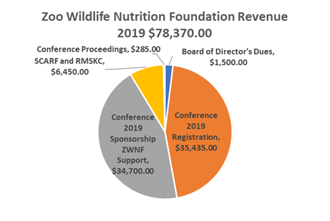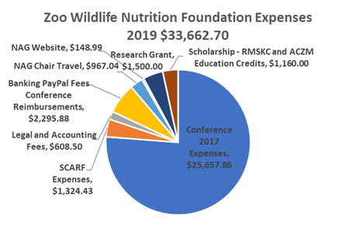

2019 was a Conference year. The Conference was held in St. Louis, Missouri, in conjunction with AAZV, and was well-attended by zoo nutrition professionals and veterinarians alike. Note that sponsorship donations and conference registration made up the largest portions of revenue, whereas conference expenses (meals, rooms, transportation, audio-visual, etc.) accounted for the largest portion of expenses. The SCARF fundraiser was the most successful to date generating $4,212.63 in revenue. The increased revenue was due to an increase in funding as well as a decrease in expenses and generous donations made for auction items. It was an entertaining evening with carnival games, an auction, and light refreshments. Also supporting our goals, funds were used for student awards/scholarship, continuing education credits, and research. For the year, revenues exceeded expenses by $44,707.30.

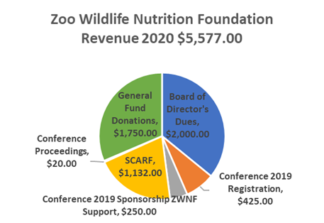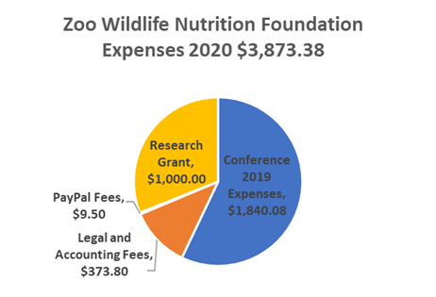

2020 was not a Conference year. There were few Conference-related additions (registrations and proceedings sales) that were accounted for in 2020 instead of 2019. Note the considerably smaller revenue total for the non-Conference year. A few conference 2019 expenses and the research grant award were the main contributors to expenses. Revenues exceeded expenses by $1,703.62, primarily due to board of director dues and general fund donations. This is the first year with unsolicited general fund contributions from a corporation and individuals. These are highlighted on our donor page.

ZWNF EDUCATION AND RESEARCH GRANTS

Normally we would offer an education & training grant. However, due to the circumstances in the world we have decided to not offer the education & training grant this year.

We have made some exciting changes to the research grant. Applications will be accepted May through August 2021. Look for the announcement on NAGNOTES and a post to NAGonline.net.

The 2021 ZWNF research grant will be available to support up to $5,000 towards qualified research and development expenses. Thanks to our fabulous sponsors and our continued tradition of content-rich conferences, we have been able to increase our support of research and development that makes a difference to the nutrition of animals under human care.

Keep an eye out for the call for grants, and please apply. If you, or your employers, are interested in providing funding to support these valuable applied nutrition training and research opportunities, please reach out to ZWNF at barbara.henry@cincinnatizoo.org.

RESEARCH GRANTS UPDATE

In 2019 the research grant was awarded to Larisa Jancewicz, to explore the use of near infra-red spectroscopy (NIRS) combined with principle component analysis (PCA) to predict the composition of whole prey and other food items fed at the Calgary Zoo. The study revealed that NIR spectra in combination with PCA can be used to predict differences in fat content among similar feed samples (different cuts of meat or crickets at various life stages) as well as feed samples that are biologically different (squid and rodents). Principle component analysis eliminates the need for costly chemical analysis of new feed samples and provides an easy tool for visualizing spectral differences and relating them to nutrient composition, particularly fat. This tool may be used to identify outlier samples that require wet chemistry to confirm their composition. The final step to complete this study will be to develop a calibration equation for fat using the samples in this study and determine how robust it is using cross validation statistics. Future work will require analysis of fat-soluble vitamins in these samples and determine if changes in their levels may be identified as patterns on a PCA graph. The study should be replicated using NIRS of fresh samples that have not been dried or ground.

CONSIDER A GIFT

The Zoo and Wildlife Nutrition Foundation was created to support the important work of not only the AZA Nutrition Advisory Group, but of the profession of zoo and wildlife nutrition as a whole. The more we learn about appropriate nutrition and diets for wildlife in human care, the greater our ability to manage and reproduce those animals and help maintain sustainable populations. The more we learn about their free-ranging counterparts, and the ability of habitats to meet the nutritional needs of those animals, the more we can help manage the animals and ecosystems for sustainability.

The Zoo and Wildlife Nutrition Foundation supports efforts in both realms – for the future of sustainable wildlife populations. We sincerely appreciate all of those who have donated to help support us to date. Please consider supporting us in our critical endeavors through a financial gift (visit the NAG website to do so: https://nagonline.net/287/sue-crissey-animal-nutrition-residency-fund-scarf/ or https://nagonline.net/zwnf/). Donations, whether large or small, go directly to achieving our mission. We appreciate your support

DONOR RECOGNITION

Thank you for your support!

$1,000-$5,000

Disney Worldwide Services, Inc.

Elsbury

Nebeker

Below $500

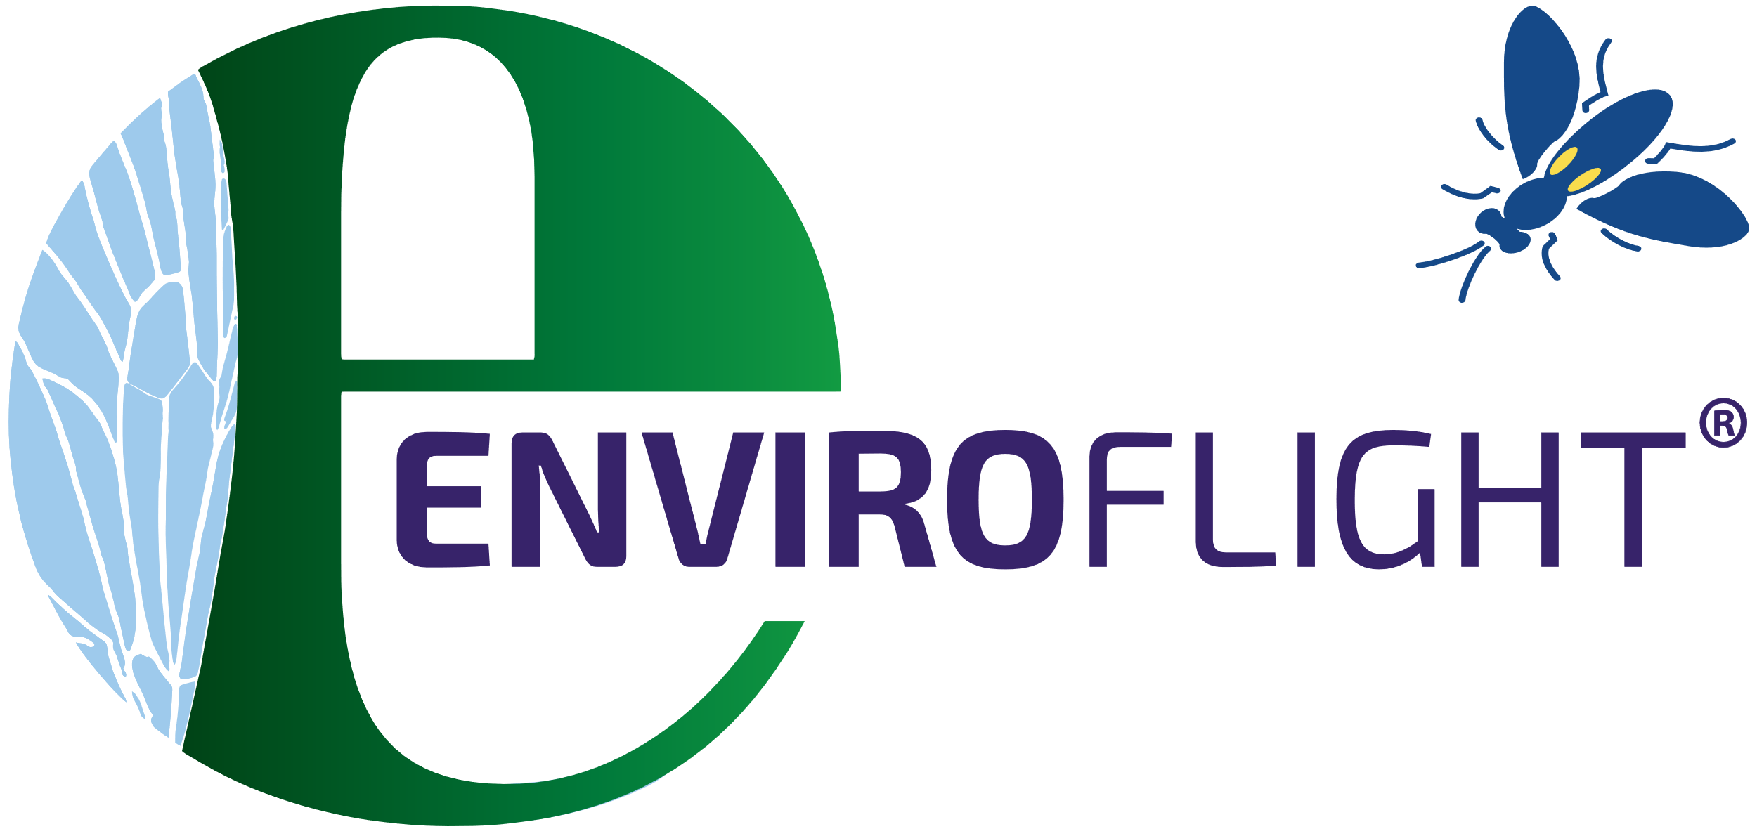

PRESIDENT

Barbara Henry, MS

VICE PRESIDENT

Mike Maslanka, MS

SECRETARY

Shannon Livingston, MSc

TREASURER

Ann Ward, MS

MEMBERS

Kerri Slifka, MS

Liz Koutsos, PhD

Mark Griffin, PhD

**BOARD OF DIRECTORS**

MEET OUR BOARD

“*My Favorite Animal is the One That Eats” -* Barbara Henry

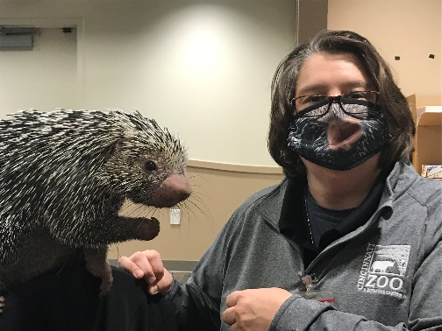Barbara Henry, M.S.

Barbara has been the curator of nutrition at the Cincinnati Zoo & Botanical Garden for the past 15.5 years and worked 10.5 years at the Brookfield Zoo as the second nutrition resident then staff nutritionist. Additionally, she loves to experiment with recipes in the kitchen and plant new perennials in her gardens.

Mike Maslanka, M.S.

Mike is the Head of the Department of Nutrition Science at the Smithsonian National Zoological Park and Conservation Biology Institute, and the Chair of the AZA Nutrition Advisory Group. He is active in clinical nutrition, lab- and field-based nutrition research, commissary operations, and day to day land resource management at both Zoo facilities.

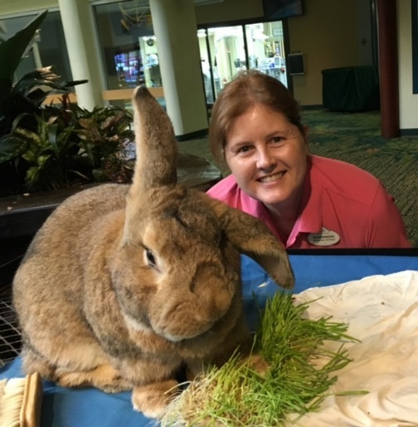Shannon Livingston, M.Sc.

Shannon has been part of the Nutrition team at Disney’s Animal Kingdom for 14 years. Prior to that, Shannon worked in the Animal Nutrition Center at the Toronto Zoo for 12 years.

Ann Ward, M.S.

Ann has been the Director of Nutritional Services (formulation, operations, and laboratory) at the Fort Worth Zoo for 27 years. Prior to that she completed the first zoo nutrition residency at the Brookfield Zoo with Sue Crissey, PhD.

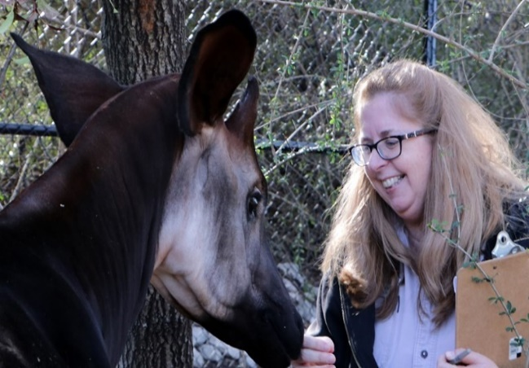Kerri Slifka, M.S.  
 Kerri has been Curator of Nutrition at Dallas Zoo for the last 15 years and serves as Nutrition Co-Advisor to the Okapi SSP and Penguin TAG. Prior to Dallas, she spent 20 years in Brookfield Zoo’s Nutrition Services Department in various roles from keeper to staff Nutritionist.

Liz Koutsos, Ph.D   
Liz has spent more than 21 years in the comparative nutrition field, working in academia, the feed manufacturing industry, consulting with zoos and aquariums, and now in rearing insects for animal feed applications. Her favorite animal, other than black soldier fly larvae, is the walrus.

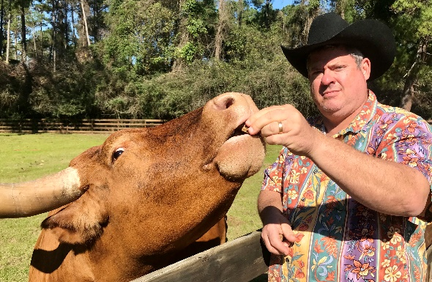Mark Griffin, Ph.D   
Mark is retired and spends much of his time in his orchard and gardens. He served as the President of Animal Nutrition at Omega Protein before it was purchased off the NYSE and taken private. Before that, Mark was with Purina Mills/Land O’Lakes and was the Director of Zoo and Aqua.

Want to be part of the Zoo and Wildlife Nutrition Foundation? Find out what it takes to apply at NAGonline.net