Supplementary information for “Impact of subtropical weather and provisioning on the body condition of feral cattle”

Supplementary information:
Supplementary information S1: Inclusion criteria of group size of Hong Kong cattle and details on group dynamics in our sample (n=262).

Tables:
Table S1: Hong Kong cattle Body Condition Score (BCS) scale summary. The scale was from 1 to 9 and was based on literature from beef cattle. As extreme scores (BCS 1 and BCS 9) were never observed, they are not included below.

Table S2: Body Condition Scores (BCS) were correlated from one week to the subsequent after training April 1st 2022 to May 5th 2022 in a cattle herd (n=60). Bold indicates significant correlation values.

Table S3: Weather variables extracted from the Hong Kong Observatory (HKO) averaged per month for the study period of body condition scoring

Table S4: Selected Sliding windows of weather variables in Hong Kong over the period of September 2022 to August 2024 were correlated to one another, though correlations were moderate (<0.5).

Table S5: Body Condition Score of Hong Kong cattle (n=252) varied by month and year, as modelled by Ordinal Logistic Regression.

Table S6: Sliding windows of Standardized Precipitation Evapotranspiration Index (SPEI) in Hong Kong over the period of September 2022 to August 2024 in non-provisioned (n= 123) and provisioned herds (n= 132), as well as females (n= 132) and males (n= 120).

Figures:
Figure S1: Body Condition Score (BCS) of Hong Kong cattle (n=252) was predicted by (A) the maximum cloud cover Sliding Window (SW); (B) the maximum sunshine SW; (C) the maximum wind speed SW and (D) the maximum Standardized Precipitation Evapotranspiration (SPEI) SW, as estimated by Ordinal Logistic Regression.

Supplementary information S1: Inclusion criteria of group size of Hong Kong cattle and details on group dynamics in our sample (n=262).

Group size represents the number of cattle that were scored at least once in a group; 16% of individuals in our sample (23 males, 19 females) were recorded changing group, leading to some individuals being accounted for in the group size of multiple herds (up to three herds). Additionally, while group size does not include calves and juveniles, individuals that matured during our two-year sampling period and were therefore scored at some point during the sampling period were included; that was the case for 13 individuals (10 males and three females). Likewise, while eight deaths (five males and three females) occurred during our sampling period, those individuals are still accounted for in group size.
Table S1: Hong Kong cattle Body Condition Score (BCS) scale summary. The scale was from 1 to 9 and was based on literature from beef cattle. As extreme scores (BCS 1 and BCS 9) were never observed, they are not included below.
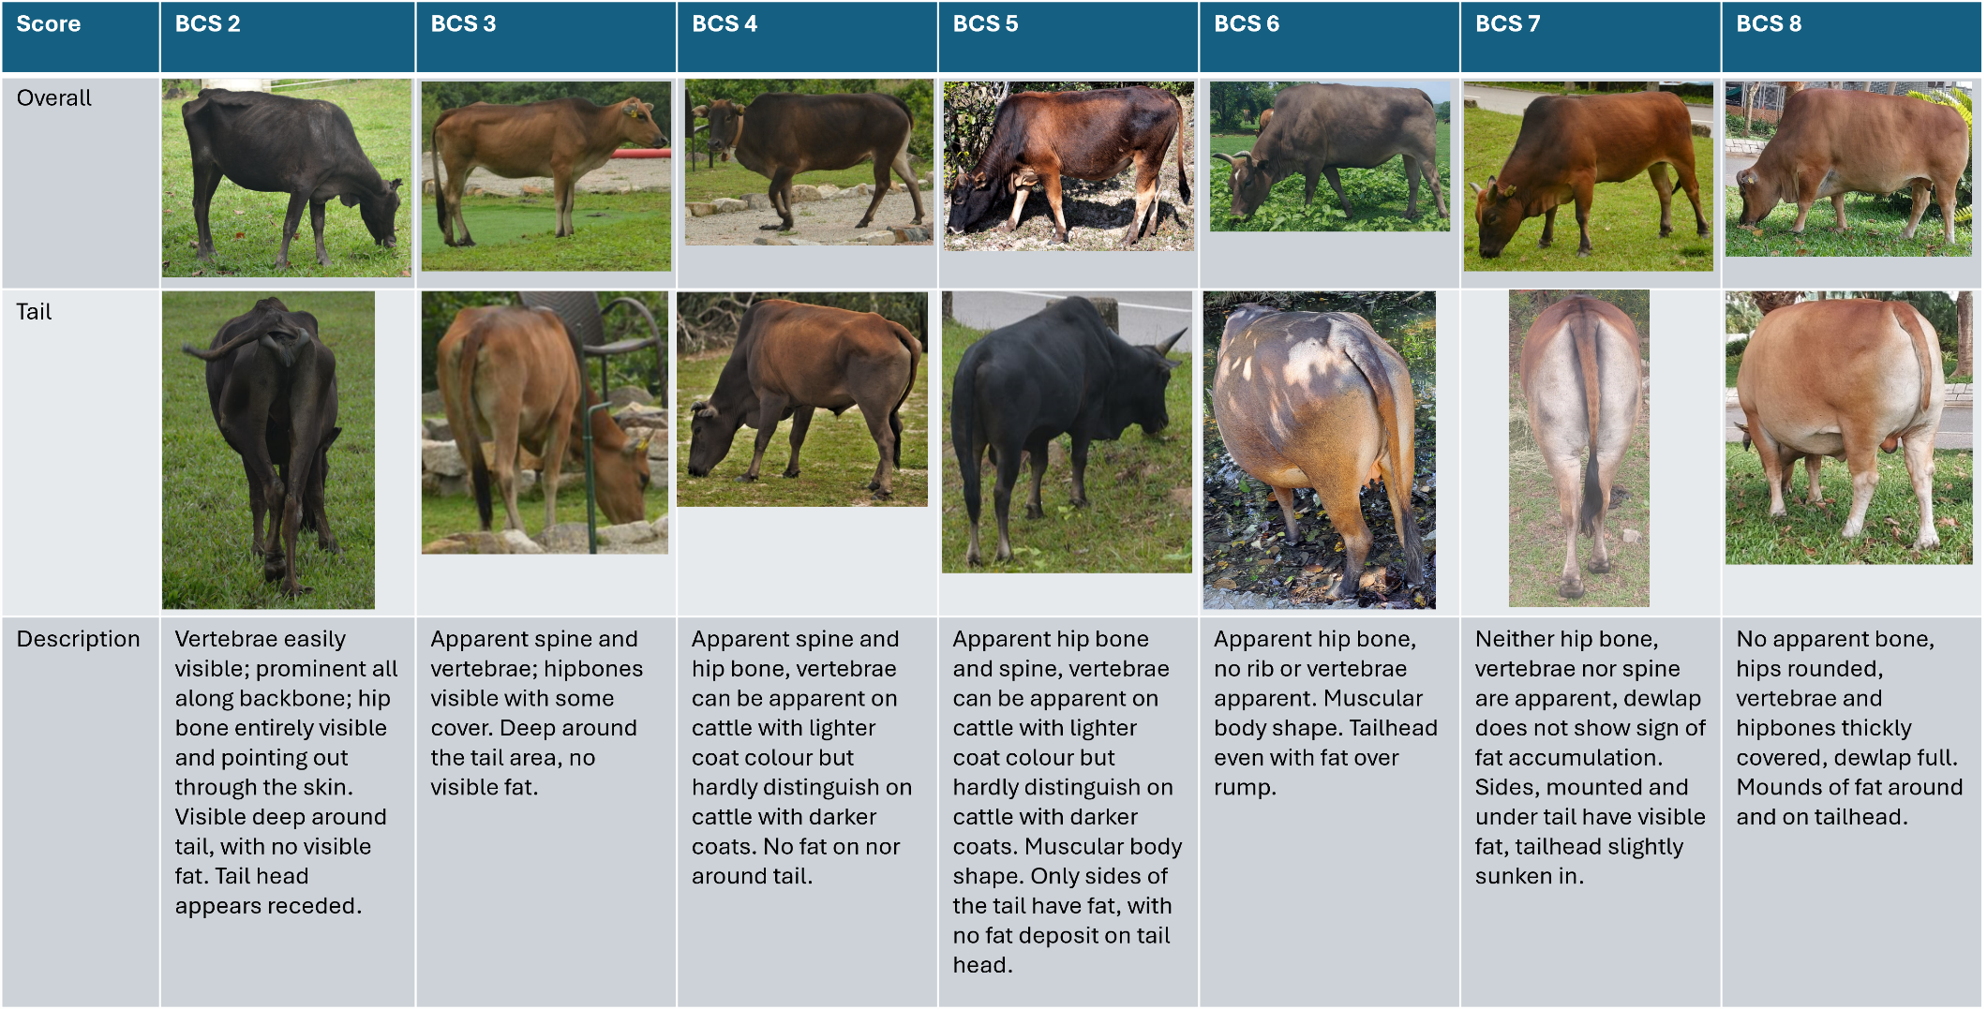
Note: This scale was adapted to the HK feral cattle based on beef cattle BCS (D’Occhio et al. 2019; Weik et al. 2021).

Table S2: Body Condition Scores (BCS) were correlated from one week to the subsequent after training April 1st 2022 to May 5th 2022 in a cattle herd (n=60). Bold indicates significant correlation values.
Scoring Date | 08/04/2022 | 14/04/2022 | 22/04/2022 | 29/04/2022 | 06/05/2022
01/04/2022 | 0.47*** | 0.13 | 0.28* | 0.25 | 0.32*
08/04/2022 |  | 0.06 | 0.25 | 0.15 | 0.06
14/04/2022 |  |  | 0.52*** | 0.45*** | 0.40***
22/04/2022 |  |  |  | 0.83*** | 0.83***
29/04/2022 |  |  |  |  | 0.86***
Note: * =p<0.05, **=p<0.01, ***=p<0.001
Table S3: Weather variables extracted from the Hong Kong Observatory (HKO) averaged per month for the study period of body condition scoring
 | Cloud Cover  (in %) | Relative Humidity  (in %RH) | Temperature  (in °C) | Total Bright Sunshine  (in hours) | Total Rainfall  (in mm) | Wind Speed  (in km/h) | THI  (in °C) | SPEI
2022
September | 53.53 | 68.63 | 29.55 | 7.91 | 5.70 | 21.53 | 80.33 | -1.95
October | 55.58 | 64.64 | 26.18 | 7.77 | 1.60 | 31.96 | 75.05 | -0.96
November | 71.2 | 82.66 | 23.4 | 3.34 | 4.36 | 27.67 | 72.53 | 1.58
December | 50.70 | 64 | 16.61 | 6.08 | 0.82 | 28.59 | 61.14 | 1.09
2023
January | 68.09 | 67.29 | 17.02 | 4.32 | 0.58 | 24.82 | 62.07 | -0.25
February | 60.42 | 73.17 | 18.85 | 5.85 | 0.05 | 26.01 | 64.82 | -1.26
March | 61.22 | 75.87 | 21.27 | 5.05 | 2.26 | 22.14 | 68.69 | 0.37
April | 81.7 | 82.26 | 23.61 | 3.07 | 2.58 | 22.31 | 72.84 | -0.51
May | 75.19 | 81.51 | 26.62 | 4.25 | 5.89 | 19.84 | 77.62 | -1.21
June | 81.96 | 82.9 | 29.19 | 5.06 | 16.36 | 17.63 | 81.96 | -0.34
July | 74.12 | 78.09 | 30.11 | 7.07 | 5.65 | 18.61 | 82.71 | -0.90
August | 80.70 | 79.51 | 29.64 | 5.44 | 4.53 | 14.76 | 82.22 | -1.26
September | 73.8 | 81.43 | 28.54 | 5.68 | 35.57 | 19.63 | 80.63 | 0.76
October | 79.12 | 75.90 | 26.45 | 4.48 | 17.61 | 28.39 | 76.65 | 1.16
November | 50.33 | 69.4 | 23.50 | 6.94 | 0.11 | 24.93 | 71.69 | -1.46
December | 71.45 | 69.96 | 19.15 | 4.38 | 0.02 | 21.68 | 65.32 | -1.58
2024
January | 62.16 | 71.74 | 17.90 | 5.47 | 0.21 | 23.32 | 63.28 | -1.34
February | 75.06 | 80.13 | 19.37 | 3.70 | 0.14 | 18.13 | 65.97 | -1.04
March | 76.74 | 77.90 | 21.08 | 3.96 | 0.69 | 21.09 | 68.56 | -0.58
April | 81.3 | 82.4 | 26.41 | 2.91 | 8.57 | 18.07 | 77.41 | 0.55
May | 83.06 | 81.80 | 26 | 3.14 | 9.43 | 22.60 | 76.66 | -0.33
June | 86.16 | 83.1 | 28.75 | 3.87 | 9.37 | 21.43 | 81.23 | -1.46
July | 78.48 | 81.45 | 29.86 | 5.75 | 14.79 | 18.49 | 82.82 | -1.13
August | 74.09 | 80.80 | 29.62 | 6.36 | 8.43 | 15.72 | 82.34 | -1.17
Note: THI = Temperature Humidity Index; SPEI = Standardized Precipitation Evapotranspiration Index
Table S4: Selected Sliding Windows (SW) of weather variables in Hong Kong over the period of September 2022 to August 2024 were correlated to one another, though correlations were moderate (<0.5).
 |  |  |  | Pearson's r | p-value
Cloud Cover SW |  | - | Relative Humidity SW | 0.169 | < .001
Cloud Cover SW |  | - | Sunshine SW | -0.302 | < .001
Cloud Cover SW |  | - | Wind Speed SW | 0.173 | < .001
Cloud Cover SW |  | - | SPEI SW | 0.030 | 0.032
Relative Humidity SW |  | - | Sunshine SW | 0.402 | < .001
Relative Humidity SW |  | - | Wind Speed SW | 0.290 | < .001
Relative Humidity SW |  | - | SPEI SW | 0.268 | < .001
Sunshine SW |  | - | Wind Speed SW | 0.190 | < .001
Sunshine SW |  | - | SPEI SW | -0.158 | < .001
Wind Speed SW |  | - | SPEI SW | 0.474 | < .001
Note: SPEI = Standardized Precipitation Evapotranspiration Index based on monthly meteorological data from the previous month

Table S5: Body Condition Score of Hong Kong cattle (n=252) varied by month and year, as modelled by Ordinal Logistic Regression.
Variable | Estimate (β) | Odds Ratio (OR) | OR 95% CI  (Lower, Upper) | P-value
Individual term
Month  Linear  Quadratic | 2.86  2.04 | 17.51  7.72 | (13.12, 23.38)  (5.56, 10.59) | < 0.0001  < 0.0001
Cubic | -083 | 0.43 | (0.26, 0.71) | < 0.0001
Interaction term (month by year)
January 2023 | 2.13 | 8.54 | (6.27, 11.55) | < 0.0001
February 2023 | 1.56 | 4.78 | (3.20, 7.14) | < 0.0001
March 2023 | 2.76 | 15.95 | (11.75, 21.56) | < 0.0001
April 2023 | 2.58 | 13.29 | (9.67, 18.26) | < 0.0001
May 2023 | 2.56 | 12.98 | (9.43, 17.93) | < 0.0001
June 2023 | 1.77 | 5.87 | (4.21, 8.34) | < 0.0001
July 2023 | 2.00 | 7.43 | (5.05, 10.83) | < 0.0001
August 2023 | 1.97 | 7.21 | (4.99, 10.53) | < 0.0001
September 2023 | -0.37 | 0.69 | (0.47, 1.01) | 0.08
October 2023 | -1.99 | 0.14 | (0.08, 0.25) | < 0.0001
November 2023 | -1.42 | 0.24 | (0.15, 0.36) | < 0.0001
December 2023 | -2.14 | 0.12 | (0.07, 0.20) | < 0.0001
Note: Odd ratios and corresponding CIs >4 indicate that the association between the predictor and the response variable is strong, between 1.5 and 4 likely indicate an effect mitigated by other predictors and <1.5 indicate low to no associations.

Table S6: Sliding windows of Standardized Precipitation Evapotranspiration Index (SPEI) in Hong Kong over the period of September 2022 to August 2024 in non-provisioned (n= 123) and provisioned herds (n= 132), as well as females (n= 132) and males (n= 120).
 | Variable | P-value | Stat | Window
Non-provisioned | SPEI 3 | 0.49 | Minimum | 4-2
 | SPEI 4 | 0.49 | Minimum | 4-1
 | SPEI 5 | 0.49 | Minimum | 3-1
Provisioned | SPEI 3 | <0.0001 | Minimum | 3.5-0
 | SPEI 4 | <0.0001 | Minimum | 3-0
 | SPEI 5 | <0.0001 | Minimum | 4.5-0
Females | SPEI 3 | <0.0001 | Minimum | 3.5-0
 | SPEI 4 | 0.02 | Minimum | 4-1
 | SPEI 5 | 0.02 | Minimum | 3-1
Males | SPEI 3 | <0.0001 | Minimum | 4-1
 | SPEI 4 | 0.02 | Minimum | 4-1
 | SPEI 5 | <0.0001 | Minimum | 4-1
Note: Total sample size ’non-provisioned + provisioned’ and ‘females + males’ differ as some individuals were observed changing herd membership overtime.

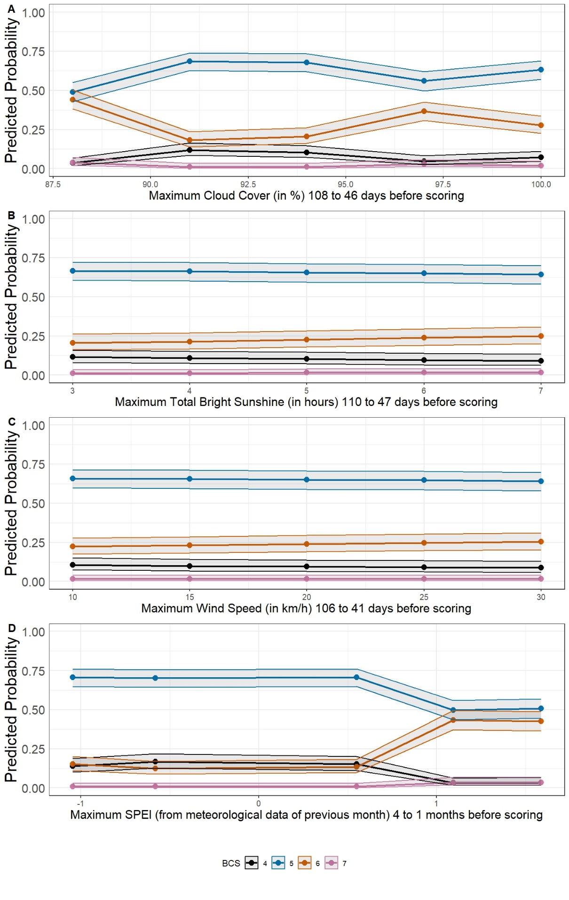
Figure S1: Body Condition Score (BCS) of Hong Kong cattle (n=252) was predicted by (A) the maximum cloud cover Sliding Window (SW); (B) the maximum sunshine SW; (C) the maximum wind speed SW and (D) the maximum Standardized Precipitation Evapotranspiration (SPEI) SW, as estimated by Ordinal Logistic Regression. Shading indicates 95% Confidence interval for numerical predictors.

