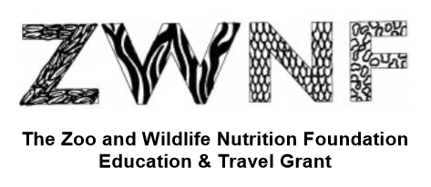

**The Zoo and Wildlife Nutrition Foundation**

**Education & Travel Grant 2025**

The Zoo and Wildlife Nutrition Foundation (ZWNF) is a non-profit organization established for the purpose of:

* contributing expertise and providing funds to support zoo and wildlife nutrition programs worldwide
* furthering the science of zoo nutrition
* facilitating the dissemination of nutrition knowledge
* developing the next generation of zoo nutrition leaders

**This Grant supports attendance at the Zoo & Wildlife Nutrition and Nutrition Advisory Group Conference Oct 19-22 in Oklahoma City.**

This grant funding may be used to support travel and/or registration costs up to $500 total value. Travel should be completed specifically for ZWNF attendance and a final report will be expected within 3 months of that time.

To apply, submit a short proposal (1 page, excluding CV) including the following information:

- How will this program increase knowledge/skill base in animal nutrition?

- How will this program support/contribute to a current or future role in animal nutrition?

- Funding amount requested from ZWNF, with details of additional funding from other sources if required for attendance

- Curriculum vitae

Timelines:

* Call for Grants 5/6/25
* Proposals due 6/6/25
* Grant awardees announced 6/30/25
* Funding provided upon on submission of receipt/payment confirmation, not later than 11/28/25
* Final report due by 11/28/25

Evaluation Criteria:

Proposals will be evaluated by members or designees of ZWNF and AZA NAG. Members or designees who could potentially benefit from grant funding will be excluded from the selection process. ZWNF board of directors and AZA NAG reviewers are not eligible for grant funding. Eligible proposals will be prioritized based on the ZWNF’s and AZA NAG’s objectives.  Grants will be awarded to institutions or organizations (not individuals) and contractual terms must be signed prior to grant award, or reimbursement of expenses (receipts are required) may be provided directly to the travel/education Grant recipient. Contract templates are available upon request.

Submit proposals to Barbara Henry, President, ZWNF, Cincinnati Zoo and Botanical Garden, 3400 Vine Street, Cincinnati, OH 45220, or via email at [Barbara.henry@cincinnatizoo.org](mailto:Barbara.henry@cincinnatizoo.org).

* Reports on projects or summaries will be viewable on the ZWNF section of the AZA NAG Website and will be included in the ZWNF annual report/updates. ZWNF must be acknowledged in all publications. A contract between the grantee and ZWNF will clearly state these requirements and use of funds. Organizations outside the US will need to provide additional documentation of tax exempt status and financial records.